

**National Representative Report November and December 2019**

In November I was asked to a conference in Brisbane but could not attend but submitted an article on “Homeless Women over 55”. It was picked up by Aloma Fennel, President of National Older Women’s Network Inc and she asked my permission to publish it in their National Newsletter. Of course, I said yes as the more people know of these women’s plight the more action can be taken. It is also in The SI Australia newsletter.

Congratulations was sent to Terese Edwards who has been elected to the management committee of eS4W. She is CEO of National Council of Single Mothers and their children which was founded in 1970. She spoke at SI South Australia Region meeting a couple of years ago and I persuaded her to join Soroptimists. She is a member of SI Adelaide.

I also attended the SCASA (Service Clubs Association of SA) awards lunch at the Glenelg Golf Club where the Premier of South Australia donates money to the best projects in the state ($14000) Soroptimist International did win for some projects. Many soroptimists attended.

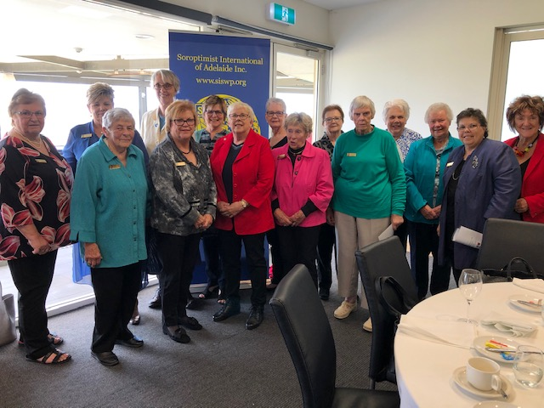

I was interviewed by ABC Hobart journalist Katri Uibi on our activism regarding backpacker safety. I sent her some information on The Slavery Links Chart, Alison Rahill’s contact and a copy of the letter SI Australia sent to the Senators in Canberra requesting they change the legislation regarding employers registering with ATO.

At the end of November I attended with Di Lockwood and Sandra Richards a conference in Adelaide CALD (Culturally and Linguistically Diverse). It was opened by Janet Anderson PSM Commissioner Aged Care Quality and Safety Commission. She spoke about inclusive care, social, cultural, linguistic, religious, spiritual, psychosocial and medical needs. All Aged Care places have accreditation to prove these things are done.

As we know there is a Royal commission into Aged Care at the moment.

There are not enough Home Care packages and 40% of aged care workers are from overseas, mainly India, Philippines and Africa. There are carer marriages that can be open to abuse. A useful website for more information is agedcarequality.gov.au.

The Conference of Clubs May 2020 in Yogyakarta Indonesia registrations are now open. It looks like it will be fantastic with great venue and speakers as well as networking with our sisters.

Meetings are currently being held to propose a change of name from SISWP to Asia Pacific to be presented in February 2020 so watch this space.

I have written congratulations to all successful Federation office bearers and wish them well

Thank you so much for being so supportive this year I really have appreciated it.

Finally, I would like to wish you all a very Merry and Safe Christmas and Happy new Year.

Kath Gribble

Soroptimist International Australia